eRecord decision making tool for lactating parents and infants being fed human milk
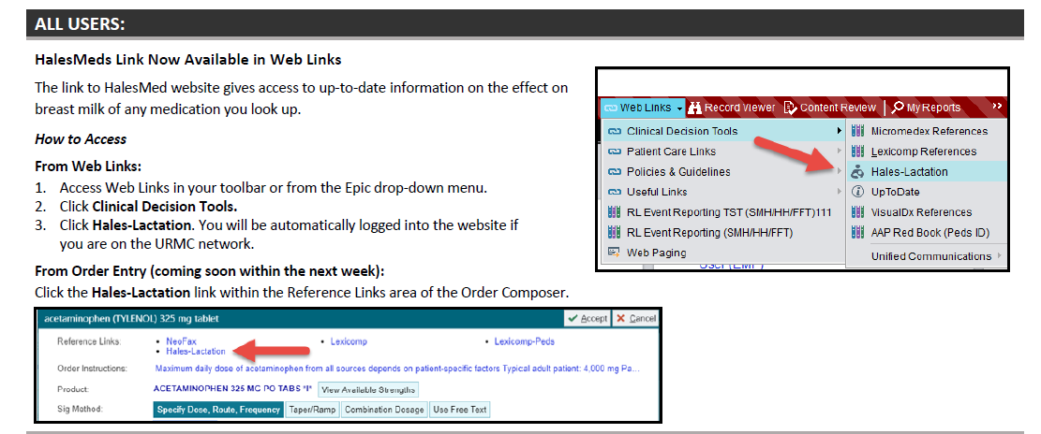

The “Hales-Lactation” link will open up a web page where you can search the medication


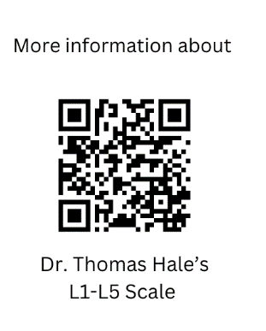
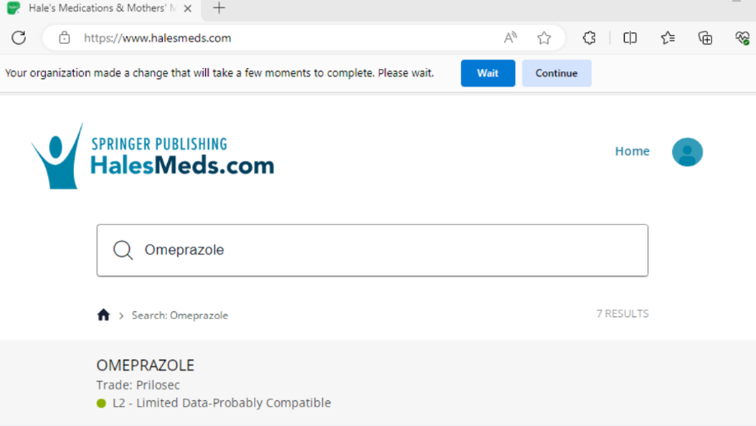

For more information, or advice regarding a patient taking multiple
medications, you may call the InfantRisk Hotline at Texas Tech University.
(806) 352-2519
L1= Compatible
L2=Probably Compatible
L3= Probably Compatible
L4=Potentially Hazardous
L5= Hazardous

